**Lab Programming Statements (Day-3)**

1. **Using input() function take one number from the user and using ternary operators check whether the number is even or odd.**

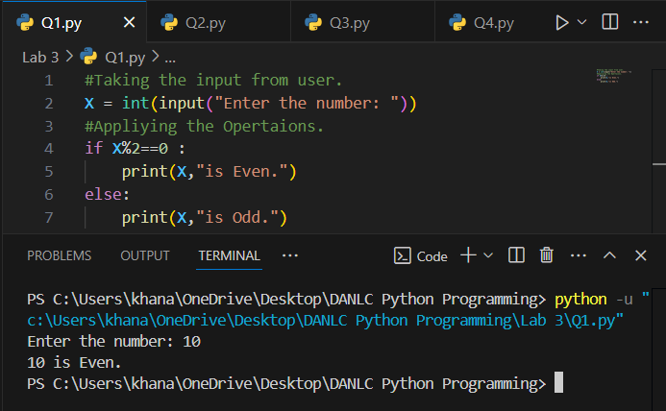

1. **Using input function take two number and then swap the number.**

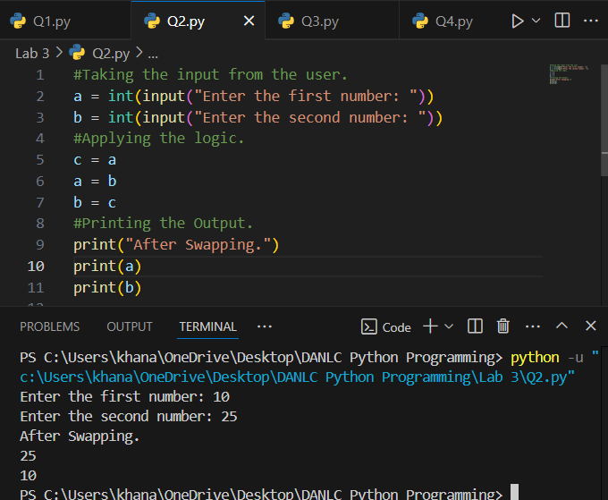

1. **Write a Program to Convert Kilometers to Miles.**

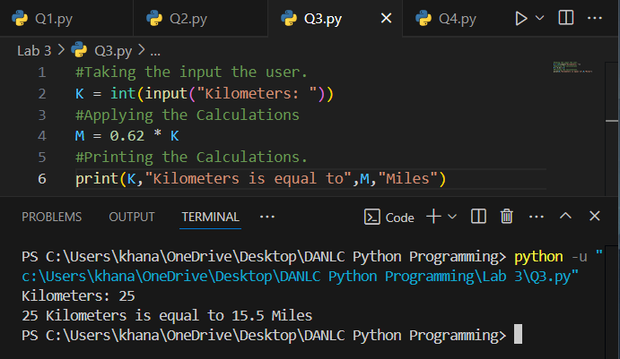

1. **Find the Simple Interest on Rs. 200 for 5 years at 5% per year.**

